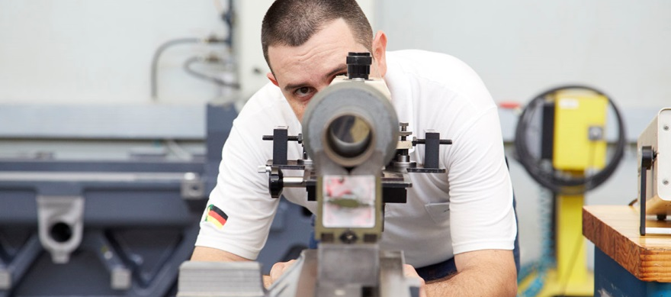
April 2015
Quality leaves a lasting impression. Globally and locally.
- HELLER in a nutshell: facts and figures
- HELLER 2014: positive trend continues
- HELLER 2015: excellent prospects
- HELLER quality: prerequisite for customer satisfaction

Press relations
Gebr. Heller Maschinenfabrik GmbH

Marketing
Marcus Kurringer
Gebrüder-Heller-Straße 15
72622 Nürtingen
Germany
Phone: +49 7022 77-5683
Fax: +49 7022 77-165683
marcus.kurringer@heller.biz
HELLER in a nutshell: facts and figures
- Order intake 2014
  - EUR 558.1m (2013: EUR 413.5m)
    - 69% Europe (2013: 66%)
    - 23% North and South America (2013: 15%)
    - 8% Asia (2013: 19%)
- Turnover 2014
  - EUR 434.4m (2013: EUR 532.7m)
- Performance 2014
  - EUR 462.5m
- Equity capital 2014
  - EUR 108.8m
  - Equity ratio: 34.5% (2013: 34.0%)
- Investment volume 2014
  - EUR 8.1m
- Development expenditure 2014
  - EUR 13.5m
- No. of employees 2014 (31 Dec 2014)
  - HELLER Group worldwide: 2,470
  - HELLER in Germany: 1,870

HELLER 2014: positive trend continues
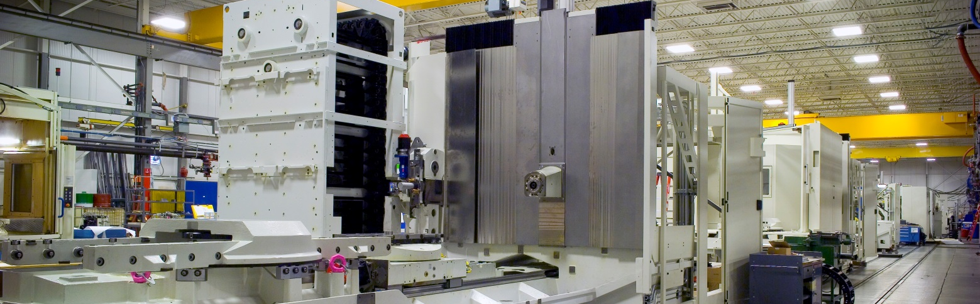
As expected, 2014 was a year of two very different halves. Development during the first six months was below average. The pickup noted in the second half of the year exceeded our forecasts in terms of both business volume and results. The 2014 order intake is also above plan with a correspondingly positive impact on the current financial year.
Order intake: strong increase
The increase in order intake noted by the German machine tool industry continued throughout 2014. On an annual basis, this resulted in 4% growth. In 2014, HELLER recorded a 35% increase in orders received to a total volume of EUR 558.1m, resulting in the second highest order inflow in the history of the HELLER Group. In particular, project business with automotive customers contributed to growth with an increase of approx. 60% on the previous year, so that we were able to exceed our forecasts for 2014.
Origin of orders: Germany and the rest of Europe as main drivers
The most substantial changes in the geographical distribution of order intake in 2014 were noted in overseas markets. Germany continues to hold the lion share, followed by the rest of Europe with 69% (previous year 66%) due to strong domestic automotive project business. At 23%, North and South America are above the previous year (15%). Here again, project business developed above average. Due to the development in China, Asia’s growth has slowed down significantly to 8% compared to the previous year (19%).
Turnover: strong second half-year
At EUR 434.4m, the turnover achieved by HELLER in 2014 was approx. EUR 98.3m below that of the previous year. As expected, development of sales split the year 2014 into two distinct halves. Due to the fact that order intake picked up strongly in the second half of 2013, and considering the usual lead times until revenue recognition, especially in project business, we had already anticipated that the weaker first six months of 2014 would be followed by a significantly stronger second half of the year. As a result, 62% of group sales were realised during the second six months of the year.
Capital resources: overall above average
Increase in inventories and capitalised services included, the total operating revenue amounted to EUR 462.5m, which is above average in multi-year comparison. The result from ordinary business activities significantly decreased year-on-year due to the heterogeneous business development throughout the year. However, the strong second half-year was not able to fully offset the shortfall in the first six months. The group's equity capital increased to EUR 108.8m, resulting in a strong equity ratio of 34.5% by the end of the year.
Investments and developments: at the previous year's level
The total investment volume in 2014 reached EUR 8.1m. The majority of this was invested in machinery, plant, operating and business equipment. New product development and product refinement as well as the enhancement of our machine series remained focal points in 2014. With a total of EUR 13.5m, expenditure in this area was approximately at the previous year's level.
Product range: comprehensive development programme contributes to success
In 2014, the focus remained on the expansion and modernisation of our product range, enabling us to better serve our existing customers and to expand business into new target customer groups and industries, attracted by the traditional strengths of HELLER such as productivity, reliability and availability. At the same time, we continued working on the expansion and intensification of our regional business.
Our current product spectrum of 4-axis and 5-axis machining centres and mill/turning centres enables machining of components of up to 10t in weight and 1,800mm in height at high productivity and process dependability. The newly added large machining centres are ideally suited for the machining of large pumps and housings for power generating and continuous-flow machinery. Other areas of application are general mechanical engineering, the oil and gas industry or aerospace.
HELLER CBC: HELLER and Daimler receive R&D 100 Award
In terms of its turnkey competence in crankcase manufacturing systems, HELLER for some time has been offering systems for the coating of cylinder bores on the basis of a twin-wire arc spraying technology. The process named HELLER CBC (CylinderBoreCoating) is a new addition to the crankcase manufacturing process chain. This process technology helped us to gain numerous manufacturing projects again in 2014 in different countries, including Germany, France and Japan.
In November 2014, the coating process received an award from US trade journal R&D Magazine, naming it one of the 100 most important high-tech products. For this technology, HELLER and Daimler also received the R&D 100 Award, also known as the Oscar of Invention.
HELLER 2015: excellent prospects
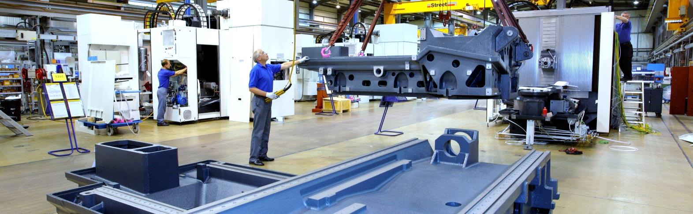
Based on the current order situation and expected utilisation, 2015 is expected to develop significantly better than 2014. There will be a substantial increase in turnover and we also expect a far more homogeneous utilisation throughout the course of the year and a noticeably improved profit situation.
Recovering markets
Provided that escalation of the crises in the known troubled regions can be prevented, we expect a very positive development in the coming years. Asia was, is and remains one of the great hopes for the future, although the Chinese market shows slight signs of consolidation. In South America, especially Brazil, the economic climate remains fragile and characterised by a significant investment backlog, which, however, is expected to clear in the medium term. Europe, too, seems to be stabilising. The current favourable economic climate in the US is expected to persist.
As far as the general business situation in our industry is concerned we agree with the leading industry associations, predicting a positive development based on the current order situation. Domestic machine tool production is expected to see another slight increase, thus reaching a new record level.

Consistent further development in all areas
We will be starting the year 2015 with an order backlog exceeding the previous year's level by approximately 50%. We also expect further lucrative contracts from project business, single machine sales and service business and anticipate a satisfactory business performance throughout 2015.

The effects resulting from ongoing improvement projects will also be contributing to this development. HELLER’s most important asset in this context remains the value-creation network of the group companies, enabling the HELLER Group to respond flexibly to fluctuations in business volumes of individual business areas or regions. We also expect added impetus from R&D, currently in the process of developing new machine types and optimising the cost of the current product range. Furthermore, systematic personnel development programmes are being implemented throughout the entire group.

In our submarkets in Europe, South America and Asia we will promote both project business and single-machine sales. For this purpose, suitable sales and service capacities have been established in target markets. Our current product range also enables us to address a growing number of customers from outside the automotive industry in the regions mentioned.

Additionally, we are further expanding our now sizeable service and spare parts business in a targeted manner. This includes strategic further development of traditional markets and targeting new business in underrepresented markets.

All in all, we believe that the HELLER Group is well-positioned in terms of markets and products with a good earnings situation at the moment and therefore expect a gratifying development of business throughout 2015.

HELLER employees: workforce expansion, also at Nürtingen headquarters
Since 2011, there have been 180 new additions to the workforce of the HELLER Group. In 2015, we will create up to 160 new jobs, most of them at our parent company.
Our aim is to set down a marker for our headquarters in Nürtingen by increasing staff levels to offset future losses due to retirement, building up capacities in production and assembly and developing expertise in 5-axis business.
Independent of the location, the high quality of the HELLER products and services is backed by dedicated and qualified staff everywhere. That is why we remain committed to not only maintain the high quality level but to globally promote and enhance it through special measures and qualification programmes. Mastering this challenge is one of the most important tasks of the HELLER organisation as a whole, also for the current business year 2015. Training and personnel development at HELLER are key to tomorrow's success. That is why the company is proud that, throughout the world, the name HELLER has for a long time been synonymous with excellent products and services as well as outstanding, renowned and sophisticated vocational education and advanced training – at all production locations.

HELLER quality: prerequisite for customer satisfaction
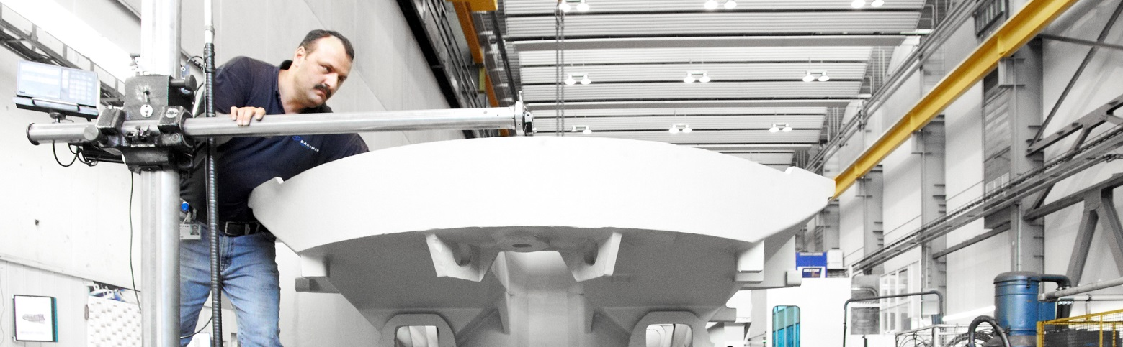
Today, HELLER counts among the leading suppliers worldwide in the most important markets of metal-cutting manufacturing – with complete solutions comprising state-of-the-art machine tools and manufacturing systems, intelligent applications and comprehensive service solutions. We believe this to be a fundamental requirement to be perceived as an important partner in the global market by our customers.
HELLER global footprint: quality anytime, anywhere, in any area
We are committed to delivering the same high level of service to our customers anywhere in the world, meeting the same high quality standards and enabling them to be optimally prepared for changes in the market or in manufacturing requirements and to operate their core business successfully. To achieve this, we have implemented a convincing concept: globally consistent quality assurance for all products and in all areas – from the machine and application through to our service network. This principle of a consistent global orientation and a strong regional presence is what we refer to as HELLER Global Footprint.
HELLER Lifetime Productivity: quality to last a lifetime
Investing in a machining centre means investing in the future: increasingly smaller batch sizes, shorter delivery times and growing complexity of components require continual optimisation and streamlining of the manufacturing process. Today, there is a growing trend towards complete machining on a single machine. Machines for complete machining allow to reduce loading times, part handling times, measuring requirements, cycle times etc. and, as a rule, increase the achievable accuracies. The possibility of complete machining is supported by multitasking, i.e. the intelligent combination of a standard machine with process and control expertise.
To achieve this, HELLER is offering Lifetime Productivity: our machining centres not only meet current requirements. They also provide the capability to be used efficiently and productively throughout their entire life cycle. By adding specific technology and process know-how, a standard machining centre can be transformed into an effective asset for efficient complete machining.
To achieve Lifetime Productivity we have built up comprehensive expertise in application engineering. Often, consistently implemented complete machining requires the use of manufacturing technologies atypical for machining centres. This includes complementary technologies such as turning, grinding, shaping, honing or the machining of gears. As an integrated solutions provider we are integrating numerous additional technologies into the core process of milling, creating future-oriented solutions implemented on standard HELLER machining centres for processes otherwise requiring special-purpose machines or complex manufacturing systems. To achieve this, we use a smart mix of technologies: the goal is not to upgrade a machine with the maximum range of functions. The key is to configure it in a way to provide the right combination of machining processes tailored to the customer's range of workpieces, keeping the effort involved within adequate and reasonable limits.
Lifetime Productivity also requires a fair partner, able to provide transparent and clearly structured services for adapting existing machinery to the new technological challenges whilst ensuring maximum availability. HELLER machines and the services provided by HELLER Services go hand-in-hand. A global presence, rapid response times and qualified customer care from HELLER Services help to ensure maximum machine availability over many years.

Short profile HELLER Group
Founded in: 1894 in Nürtingen
Workforce 2014: 2,470
Order intake 2014: EUR 558m
Turnover 2014: EUR 434m
Chairman of the Board: Berndt Heller
Managing Directors: Manfred Maier, Klaus Winkler
Fields of business: Horizontal machining centres, 5-axis machining centres, mill/turning centres, flexible manufacturing systems, crankshaft and camshaft machines, CBC systems, services
Production locations: Germany (Nürtingen)
United Kingdom (Redditch)
USA (Troy/Michigan) Brazil (Sorocaba)
China (Changzhou)
Sales/Service locations: EUROPE:
Germany (Hattingen, Salem, Goslar, Saarbrücken,
Nürnberg, Nürtingen)
Italy (Verona) France (Paris)
Poland (Posen) Spain (Barcelona, Santander)
Sweden (Värnamo)
Switzerland (Niederbüren)
Slovakia (Vráble)
Russia (Yekaterinburg)
NORTH/SOUTH AMERICA
Mexico (Querétaro) Brazil (Belo Horizonte, Gravataí, Joinville)
ASIA
China (Beijing, Chongqing, Shanghai)
India (Pune)
Thailand (Bangkok)
Singapore

